**Postman tests**

**Test 1: Get all movies from the database**

**Test 2: Get by movie ID from the database**

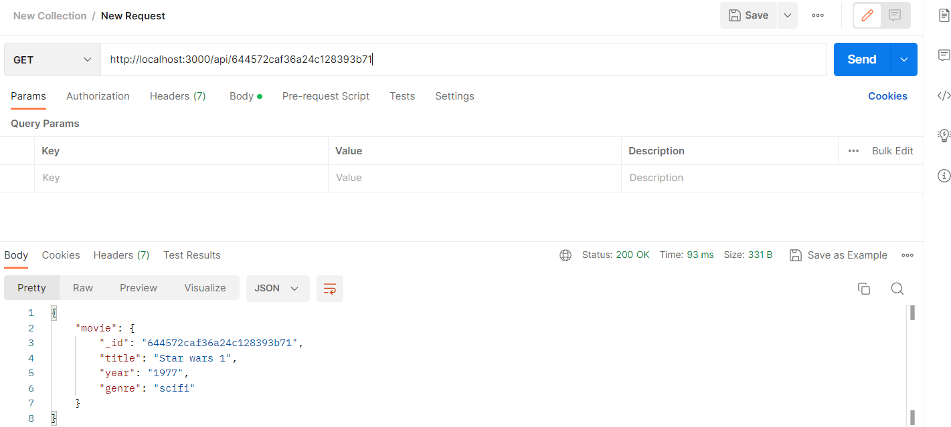

**Test 3: Add movie to the database**

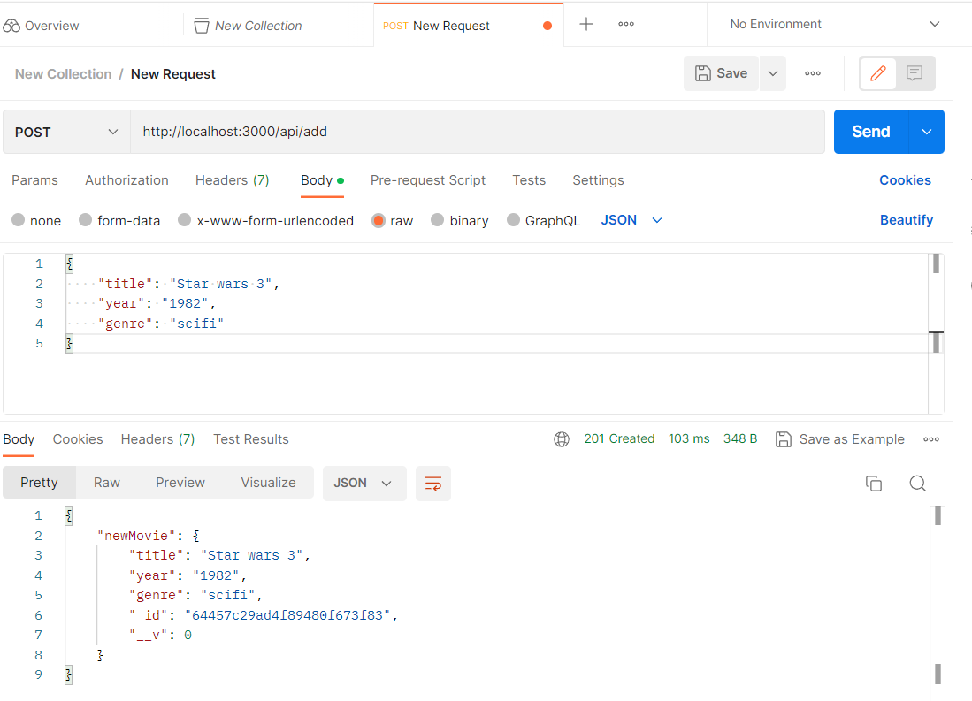

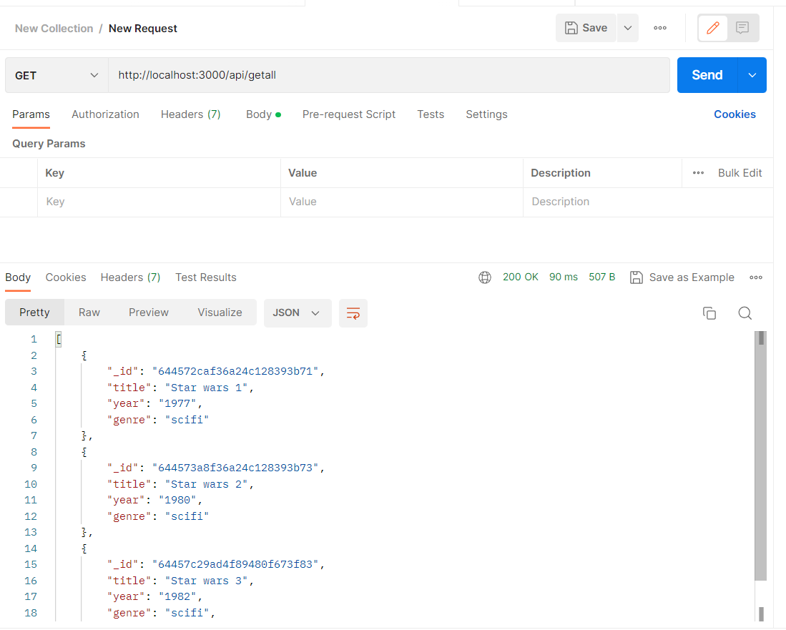

**Test 4: Update movie’s year by movie ID in the database**

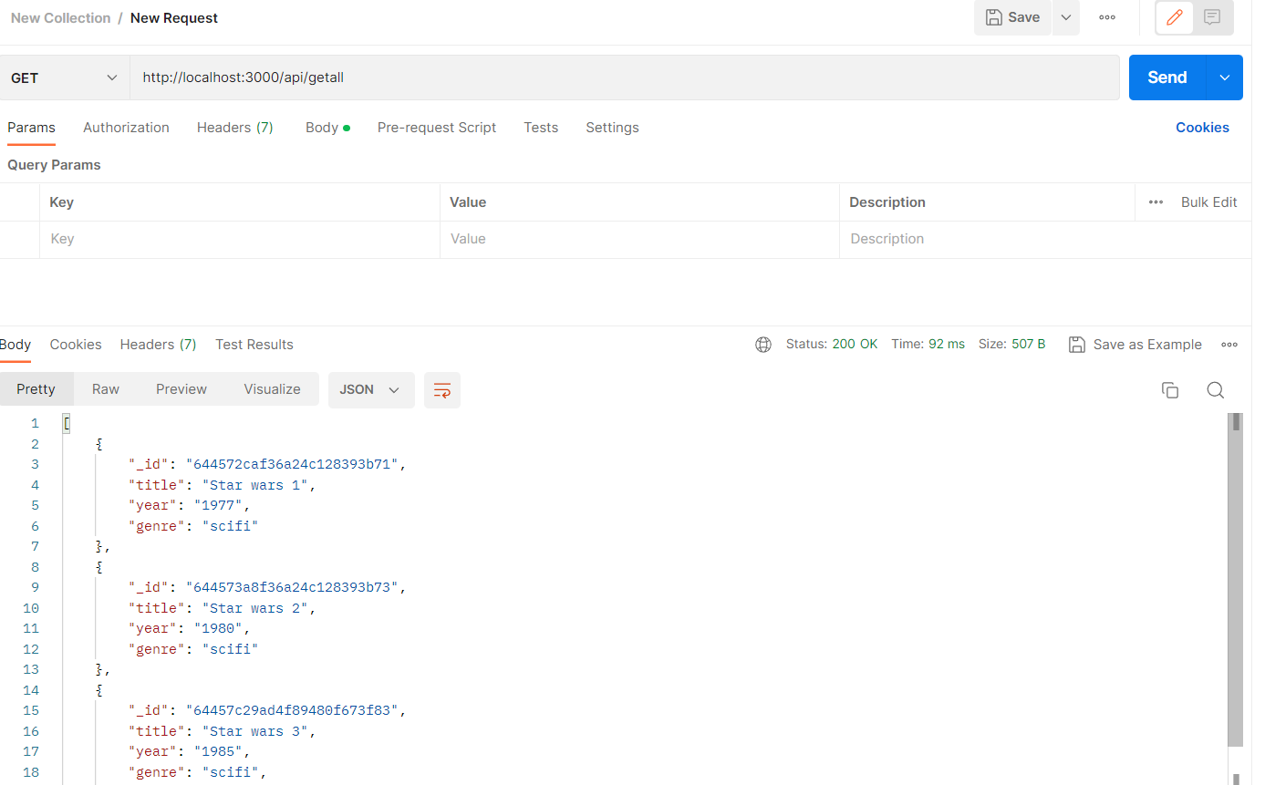

**Test 5: Delete movie by ID from the database**

